Interacting with , exploring knowing and using my environment. (LAII)

**L.A01:**

Exploring and knowing my immediate environment.

**Competence:**

Identifies and talks about his / her home

**Materials:** real objects like cups

* Visual aids

**Procedure:**

Let the teacher introduce the lesson with a rhyme

There x 3

There at home there is mum and daddy

Sister and brother

And a little baby

* let the teacher show cutouts of a home.
* Learners will indentify the home

**Activity**

Shade your home.

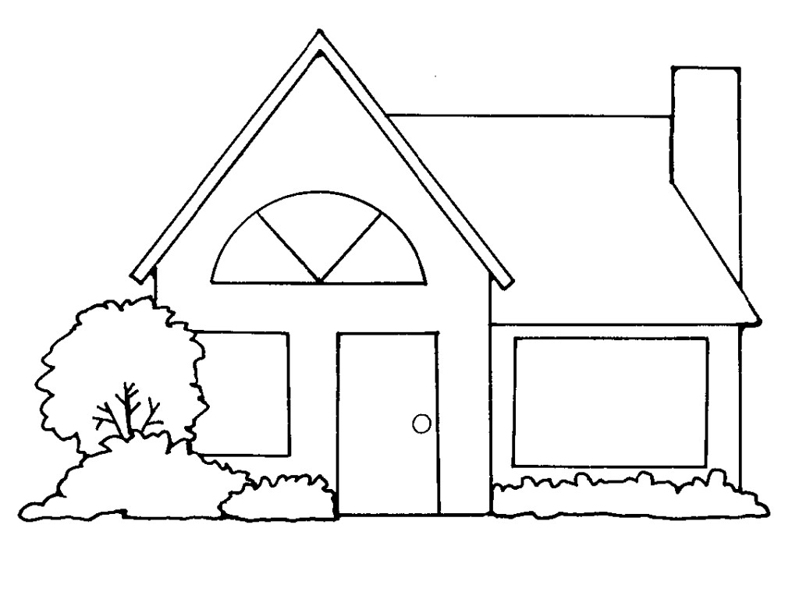

**LESSON 2 , 3 AND 4**

**Procedure:**

Let the teacher introduce the lesson with a song.

Mummy is cooking x2

What a nice family

* The teacher will show real objects found at home
* Learners will indentify things found at home.

**Activity:**

Trace things at home.

**Competence:**

Classifies people, animals, insects and other objects I see at home.

**Materials:** - visual aids

* Picture cutouts

**Procedure:**

Let the teacher introduce the lesson with a rhyme

Cow x 3

You my friend

You give me milk

And meat to eat

* Teacher will show flash cards of animals at home.
* Learners will indentify animals found at home.

**Activity 1:**

Shade a cow and a cat

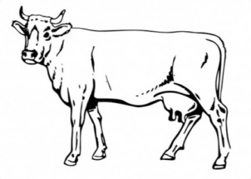 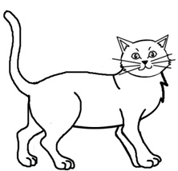

**LESSON 2**

**Procedure:**

Let the teacher introduce the lesson with a song

Daddy has a dog

A big x2 dog

A dog says boo-boo

* The teacher will show flash cards of animals at home.
* Learners will identify animals at home.

**Activity:**

Trace a cat



**LESSON 3 AND 4**

**Procedure:**

Let the teacher introduce the lesson with a song.

Am not a cow but if

Am a cow them moo moo

* Let the teacher show flash cards.
* Learners will indentify the animals found at home like goat, pig, sheep

**Activity:**

Match the same animals

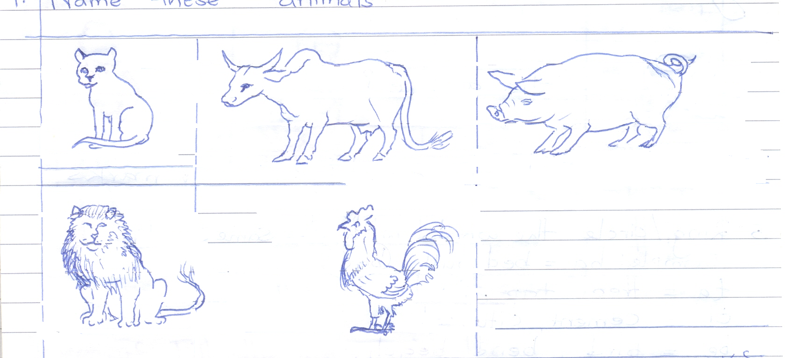 AN01060_

AN01060_ 

 

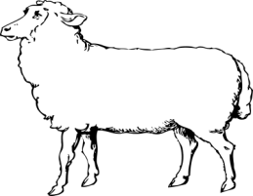 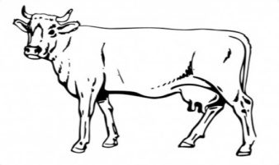

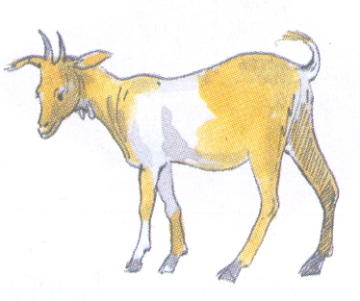 

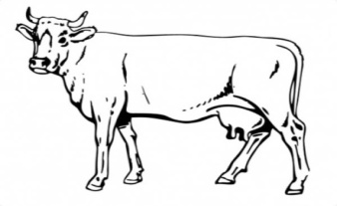 

**LESSON 1**

**Competence:**

Classifies insects at home

**Materials** – visual aids

**Procedure:**

Let the teacher introduce the lesson with a song

Butterfly x 2

I can fly

Only to fly

Oh down x 2 a bit

* The teacher will show flash cards of the insects.
* Learners shade a butterfly

**LESSON 2**

**Activity**

Shade a cockroach

MC900346899[1]

**LESSON 3:**

Shade a mosquito

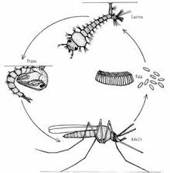

**LESSON 4**

Shade a grasshopper

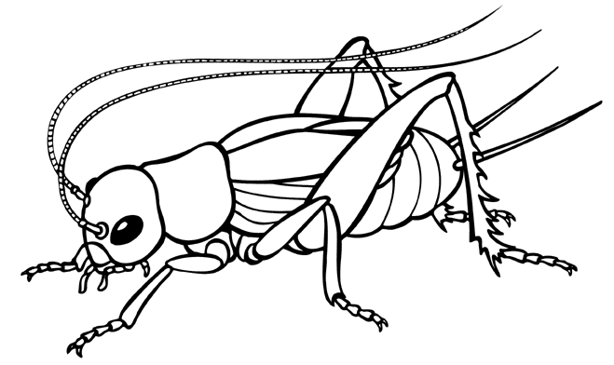

**Competence:**

Classifies objects at home

**Materials** – visual aids

* Flash cards

**Procedure:**

Let the teacher introduce the lesson with a song.

I have a nice family x 2

Father, mother, sister

Brother and a baby too

* Let the teacher show flash cards of things found at home.
* Let the learner identify the things found at home.

**Activity 1-2**

Match the things found at home.

 MCj03110200000[1]

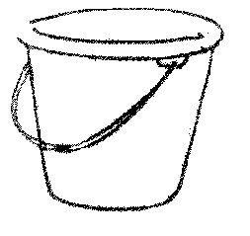 

MCj03110200000[1] 

**Activity 3 and 4**

**Copy and draw**

|  |  |  |  |
| --- | --- | --- | --- |
| HH01672_ | NA00809_ | https://encrypted-tbn2.gstatic.com/images?q=tbn:ANd9GcTBlnJ9rmbwIrxWhxcGqgqy24zd3t29bgqSU3dtEm1yBkEAcwzk |  |
|  |  |  |  |

**L.O. IV**

Identifying dangers in my environment and taking precautions.

**Competence:**

Recognizes dangerous things and situations in his / her environment.

**Materials:** - real objects

* Visual aids
* Flash cards

**Procedure:**

* Let the teacher introduce the lesson with a song.

Fire is burning x 2

Fire fire fire x 2

Pour on water x 2

* Let the teacher show the flash cards of dangerous objects
* Let the learner identify the dangerous objects.

**Activity:**

Shade the dangerous objects

|  |  |  |  |
| --- | --- | --- | --- |
|  | stick-clipart-word-stickstick-clipart-word-stick | MC900112970[1] | J0188519 |
| a1cbbf93af84673bb07c943bf43ca0ba | Description: MC900112302[1] | kTKnKyrBc |  |

**Activity 4:**

Trace the dangerous objects

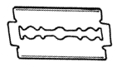 MC900112970[1]

**Activity 5:**

Match the same

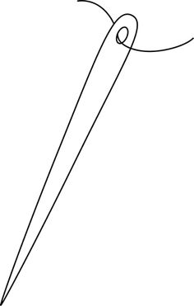 

 





**MORE PRACTICE WORK TERM I**

**LEARNING AREA 2 (ENGLISH)**

**THINGS IN THE ENVIRONMENT**

**Trace**

****

**Trace**

****

**Trace**

**Trace**

**Trace**

**Trace**

**Trace**

****

**Match the same**

 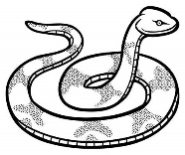

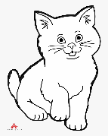 

 

**Match the same**



 



**Match**

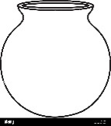 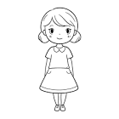

 

 

Match

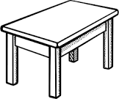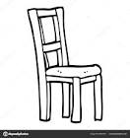

 

 

**Match the same**

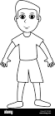



Match

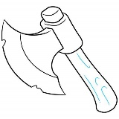

 



**Match**

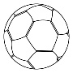 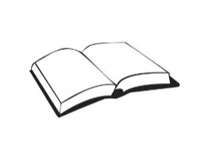





**Things used to clean the environment**

**Activity**

**Circle the same**

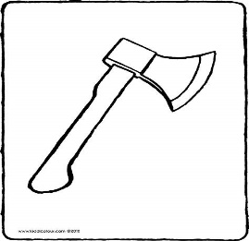  

  



**Circle the same**

  

 



**Circle the same**

  

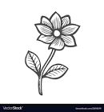  

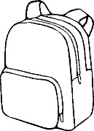  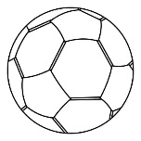

**Circle the same**



 

  

**Circle the same**

  

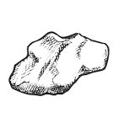 

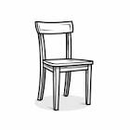 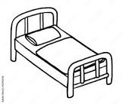 

**Circle the same**

****

** **

** **

**Copy the same**

|  |  |
| --- | --- |
|  |  |
|  |  |

**Copy the same**

|  |  |
| --- | --- |
|  |  |
|  |  |

**Copy the same**

|  |  |
| --- | --- |
|  |  |
|  |  |